# A:\CBHE-factori\aa-starter\Factori_soumis\communication\logo\Logo Factori 4.0.png

# From Automation and Control Training to the Overall Roll-Out of Industry 4.0 Across South-East Asian Nations

# (ASEAN FACTORI 4.0)

**PROJECT No. 609854-EPP-1-2019-1-FR-EPPKA2-CBHE-JP**

**Courses Lab of all new designed courses** **(CPP-Internship 2) on November 21, 28, 2022**

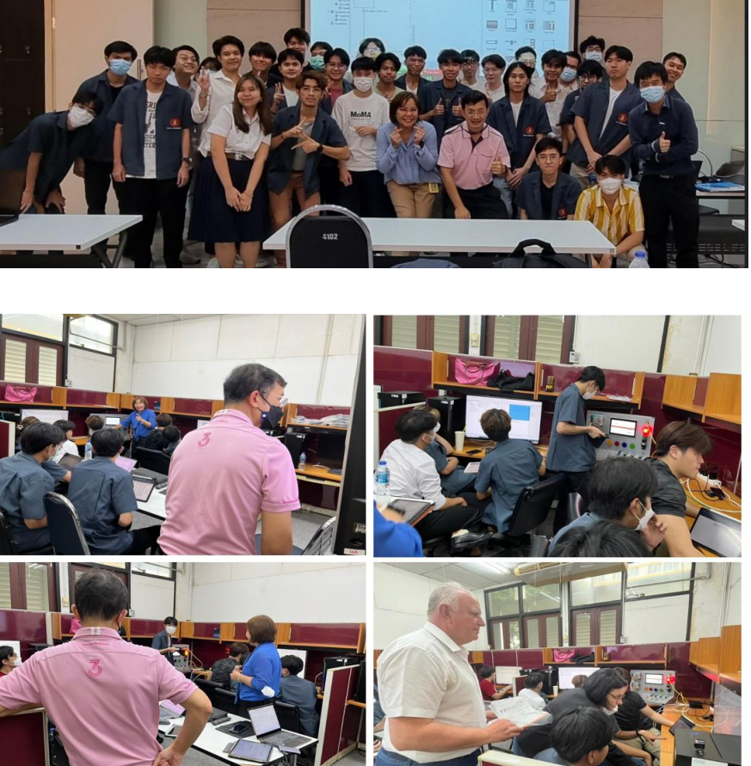

The same groups of students who participated in Seminar 2 where they learned about theory of PLC and its application, further, delved into the practical applications of PLCs across diverse industries. Through the examination of real-world case studies, they developed a comprehensive understanding of how PLCs were utilized to optimize and streamline complex industrial processes. This knowledge empowered them to identify automation opportunities and made informed decisions aimed at enhancing efficiency and productivity.

By actively participating in this seminar, students acquired the necessary expertise to thrive in the ever-evolving field of industrial automation. They were equipped with the knowledge and skills required to tackle the challenges and harness the opportunities presented by Industry 4.0.